Command Related to GIT Configuration:
PART-1 (GIT)
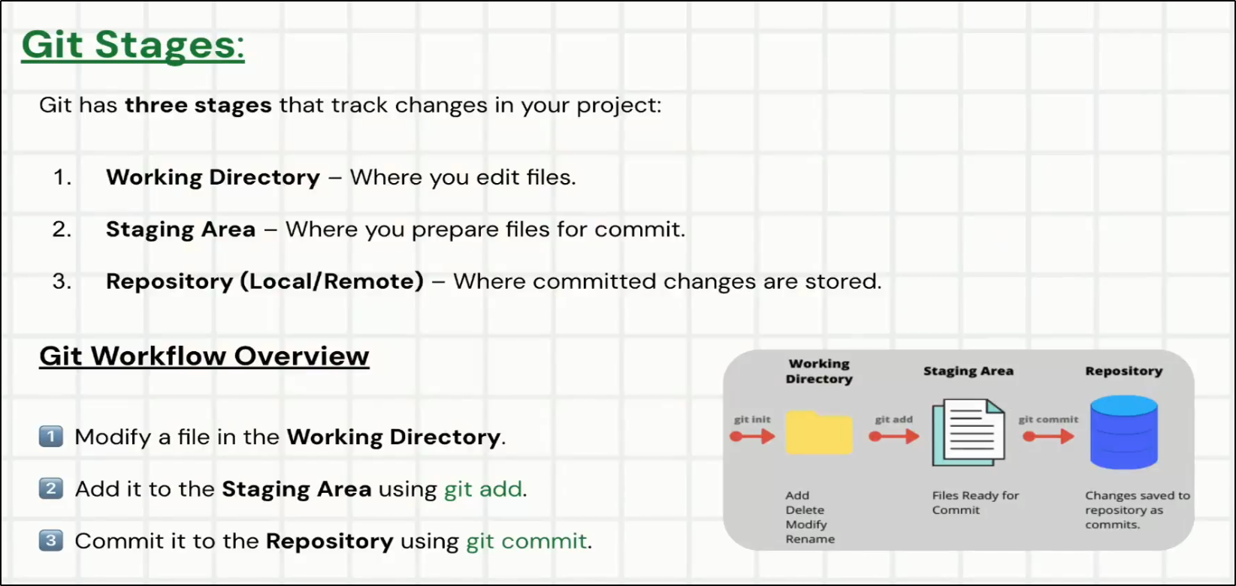
- Initial Setup:
- git config --global user.name "Your Name"
Ex: git config --global user.name "Sumit Mondal"

- git config --global user.email "youremail@example.com"
Ex: git config --global user.email Sumit.Mondal@fisglobal.com

- List all configuration:
Ex: Git Config –list

- Initialize GIT to any folder:
Ex: GIT INIT

- GIT HELP: This is your go-to command for getting detailed information about a specific Git command. It opens the full manual page (often called a "man page") in your terminal's default viewer.
Syntax: git help <command>
Command | Example | Use Case
Full Manual | git help commit | Get the most detailed information on a command.
Quick Summary | git log -h | A quick, in-terminal reminder of common options.
Web Browser | git help -w branch | Read the full manual in an easy-to-read browser view.
List All Commands | git help --all | Discover new commands or find one you've forgotten.
Conceptual Guide | git help workflows | Learn about Git concepts and best practices, not just commands.

- Basic Command - 1
- GIT ADD: git add is a fundamental command, but its variations are what make it truly powerful. It's the command you use to move changes from your working directory to the "staging area" (or "index")
Command | Example | Use Case
Add a specific file | git add index.html | The safest, most explicit way to add.
Add all changes | git add . | Stage all new/modified files in the current dir. Use after git status.
Add all repo changes | git add -A | Stage everything, including deletions, across the whole repo.
Add by pattern | git add '*.js' | Stage all files matching a pattern (e.g., all JavaScript files).
Add by directory | git add src/components/ | Stage all changes within a specific folder.
Interactive Add | git add -p | Highly recommended. Review changes hunk-by-hunk before staging.
Unstage a file | git restore --staged <file> | Correct a mistake by removing a file from the staging area.

- GIT COMMIT
  - git commit is the command that saves a snapshot of your currently staged changes to your local repository's history. Think of it as creating a permanent save point in your project's timeline.
  - Each commit has a unique ID and is accompanied by a descriptive message.
Command | Use Case | What It Does
git commit -m "..." | The standard commit. | Commits staged changes with a short, inline message.
git commit | For detailed changes. | Opens an editor for a longer, multi-line commit message.
git commit --amend | Fixing the last commit. | Modifies the most recent commit. Use on local, unpushed commits only.
git commit -am "..." | A quick shortcut. | Stages all tracked, modified files and commits them in one step.
git commit --allow-empty | For workflow automation. | Creates a commit with no code changes.

- GIT STATUS
- git status is your primary tool for seeing the current state of your project. It shows which files have been modified, which are staged for the next commit, and which new files Git doesn't know about yet.

Command | Use Case | Output Style
git status | The standard, for beginners. | Verbose, descriptive, and easy to understand.
git status -s | A quick glance for experts. | Compact, with two-letter codes for file status.
git status -b | Checking sync with remote. | Verbose, but includes branch tracking info at the top.
git status -sb | The "pro" command. | Compact, combining branch tracking and short file status.

- ' ' = unmodified
- M = modified
- T = file type changed (regular file, symbolic link or submodule)
- A = Added (new file)
- D = deleted
- R = renamed
- C = copied (if config option status.renames is set to "copies")
- U = updated but unmerged

4. GIT RM: is used to remove files from your Git repository, but it's more than just a file deletion. It performs a deletion that is immediately staged for commit.
Command | Use Case | What It Does
git rm <file> | The standard deletion. | Deletes a file from both the working directory and Git's index.
git rm --cached <file> | Remove from Git's tracking only. | Removes a file from Git's index but keeps it on your disk.
git rm <pattern> | Delete multiple files at once. | Deletes all files that match the specified pattern.
git rm -f <file> | Force a deletion. | Forcefully deletes a file with uncommitted changes. Data is lost.
git restore <file> | Undo a git rm mistake. | Restores a deleted file from the last commit.

5. Git log: It is a fundamental Git command that displays the history of commits in a repository.
Command / Flag | Description
$ git log | Displays the default, detailed commit history. Shows the full commit hash, author, date, and commit message.
$ git log –oneline  git log --oneline -n 5 | Condenses each commit to a single line, showing the short hash and the commit message title. Ideal for a quick overview.
$ git log --graph --oneline --all | Draws a text-based graph in the margin showing the branch and merge history. Extremely useful with --oneline.
$ git log --stat | Shows statistics for each commit, including which files were changed and the number of lines added (+) and removed (-).
$ git log -p -2 (shows patch for the last 2 commits) | Shows the actual code changes (the "diff" or "patch") introduced in each commit. This is the most detailed view.
$ git log --author="Alex" | Filters the log to show only commits made by a specific author. You can use their name or email address.
$ git log --since="1 week ago" | Filters commits by date. You can use relative dates (e.g., "2 weeks ago") or absolute dates (e.g., "2025-10-01").
$ git log -- src/App.js | Displays the commit history for a specific file or directory.
$ git log -S"database.connect" | Searches for commits that introduce or remove a specific string in the code (the diff). This is very powerful for finding when a particular line of code was changed.
$ git log -n 5 (shows the last 5 commits) | Limits the number of commits shown in the output.

6. Git BLAME: It is a used to examine the content of a file line by line.
Command / Flag | Description
$ git blame src/app.js | The standard command. It annotates each line of a file with the commit hash, author, and timestamp of the last modification.
$ git blame -L 10,25 style.css | Restricts the output to a specific range of lines within the file. This is useful for focusing on a particular function or block of code.
$ git blame -e main.py | Displays the author's email address in addition to their name. The default view only shows the name.
$ git blame -w config.yaml | Ignores whitespace changes when blaming. This helps you find the author who made functional changes, not just stylistic ones like indentation.
$ git blame -C components/ui.js | Detects lines that were moved or copied from other files within the same commit and credits the original author.
$ git blame -M user_controller.rb | Detects lines that were moved or copied from other files, even if they were modified in a previous commit. This is more computationally intensive.
$ git blame a8b4b75 -- src/index.html | Shows the blame for a file as it existed at a specific commit in the past. Use a commit hash to see the file's history at that point in time.

Option | Description | Example
-L <start>,<end> | Show blame only for a specific range of lines | git blame -L 10,20 app.js
-e | Show author’s email instead of name | git blame -e app.js
-w | Ignore whitespace changes | git blame -w app.js
-C | Detect lines moved/copied from other files | git blame -C app.js
--date short | Show shorter date format | git blame --date short app.js
--show-name | Show original filename if file was renamed | git blame --show-name app.js

7. GIT SHOW:
- It is used to display detailed information about a single Git object, such as a commit, tag, or tree.
  - By default, without any arguments, it shows the most recent commit (HEAD).

Command / Flag | Description
$ git show | Displays details for the most recent commit (HEAD), including its metadata and a full diff of its changes.
$ git show a8b4b75  $ git show feature-branch  $ git show v1.0.0 | Displays details for a specific Git object. This can be a commit hash, branch name (shows the latest commit on that branch), or tag name.
$ git show --stat | Shows the commit's metadata along with a summary of which files were changed and how many lines were added/removed, instead of the full diff.
$ git show --name-only | A very clean option that only lists the file paths that were modified in the commit. It omits all other metadata and diff content.
$ git show --oneline a8b4b75 | Condenses the commit information to a single line, followed by the full diff.
$ git show --quiet | Suppresses the diff output and only shows the commit information (metadata).
$ git show a8b4b75:src/app.js | A powerful feature that shows the raw content of a specific file as it existed at that particular commit.

6. GIT LAB vs GIT ACTION
- GitLab
  - GitLab is a complete DevOps platform that covers the entire software development lifecycle. It's a single application that includes Git repository management, CI/CD, issue tracking, project management, security scanning, and more. This means that GitLab CI/CD is deeply integrated into the GitLab platform itself.

- GitHub Actions
  - GitHub Actions is a CI/CD service offered by GitHub, which is primarily a Git repository hosting service. While GitHub Actions provides robust automation capabilities, it's an add-on feature to GitHub's core offering.

Feature | GitHub Actions | GitLab
Primary Focus | CI/CD and automation within GitHub repositories | Complete DevOps platform (repo, CI/CD, issues, etc.)
Integration | Tightly integrated with GitHub's repository service | Deeply integrated across its entire platform
Scope | Primarily for automation and CI/CD | Full software development lifecycle management
Runner Options | GitHub-hosted and self-hosted runners | GitLab-shared and self-hosted runners

7. . gitignore: A .gitignore file lists files and folders that you don’t want Git to include in version control.
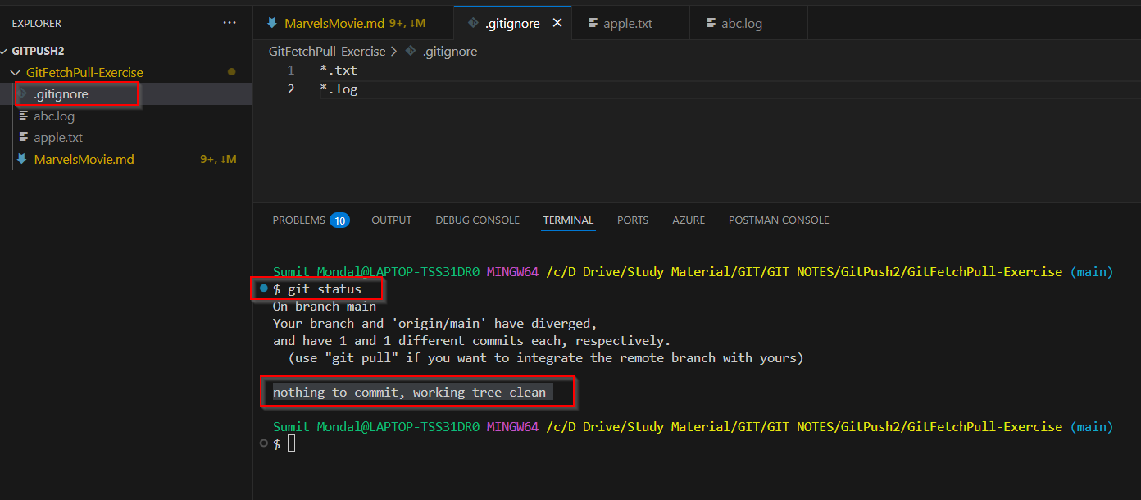

PART-2 (GIT)
- HEAD is a special pointer that represents the current commit your working directory is based on.

- git switch
Command | Use Case | What It Does
git switch <branch> | The standard switch. | Moves your HEAD to an existing branch.
git switch -c <branch> | Starting new work. | Creates a new branch and switches to it in one step.
git switch - | A quick toggle. | Switches back to the last branch you were on.

- git branch
Command | Use Case | What It Does
git branch | See your work. | Lists all local branches.
git branch -vv | Get detailed info. | Lists local branches with commit and remote tracking details.
git branch <name> | Prepare for new work. | Creates a new branch but does not switch to it.
git branch -d <name> | Clean up after merging. | Safely deletes a merged branch.
git branch -D <name> | Discard a bad feature. | Forcefully deletes a branch, even if unmerged.
git branch -m <name> | Fix a typo. | Renames the current branch.
git branch -a | Get the full picture. | Lists all local and remote branches.

- git merge
Command | Use Case | Resulting History
git merge <branch> | Standard merge. | Fast-forwards if possible, otherwise creates a merge commit.
(Resolving Conflicts) | When Git needs help. | You manually fix files, then git add and git commit to finish.
git merge --squash <branch> | For a clean history. | Combines all feature branch commits into a single new commit on the base branch.
git merge --no-ff <branch> | Preserving branch context. | Forces a merge commit even if a fast-forward is possible.

- .git folder:
- objects
This is the database for your project. Git doesn't store your files in the way you see them; instead, it compresses and stores them as unique "objects."
- Blob: A single version of a file.
- Tree: A list representing a directory, pointing to the blobs and other trees inside it.
- Commit: A snapshot of your project at a specific time. It points to a single tree and includes metadata like the author, date, and a pointer to the previous commit(s), forming a linked history.

- refs
This folder contains all of your pointers or references to commits. These are lightweight labels that make it easy to refer to specific points in your history.
- refs/heads: This is where your branches live. A file like main or feature/login is just a simple text file containing the 40-character hash of the latest commit on that branch.
- refs/tags: This holds your tags. A tag is a pointer to a specific commit, often used to mark release points like v1.0.

- HEAD: This is one of the most important files. HEAD is the "You are here" marker. 📍 It's a pointer that tells Git what branch and commit you are currently working on. Usually, it points to a branch (e.g., ref: refs/heads/main), but when you're in a "detached HEAD" state, it points directly to a commit hash.
- Index: This file is Git's staging area. When you run git add, Git takes the content you've added, creates objects for it, and lists them in the index file. This is the list of changes that will be included in your next commit.
- Config: This file contains configuration settings specific to this repository. These settings can override your global Git configuration.
- Hooks: This is a powerful feature for advanced users. The hooks directory contains example scripts that you can activate to run automatically at certain points in Git's workflow, such as before a commit (pre-commit) or after a push (post-push).

- Objects - (blue)These represent the files and changes. Objects can be further divided into commits, trees, and blobs.
- Refs - (red)These are human-readable files that organize the objects
- Logs - (green)These are used to quickly generate logs displayed to the user.
- Config - (light gray) There are files used to config git’s behavior
- Temp - (gray)These are temporary files for information that git needs to hold between command-line actions.

PART-3 (GIT)
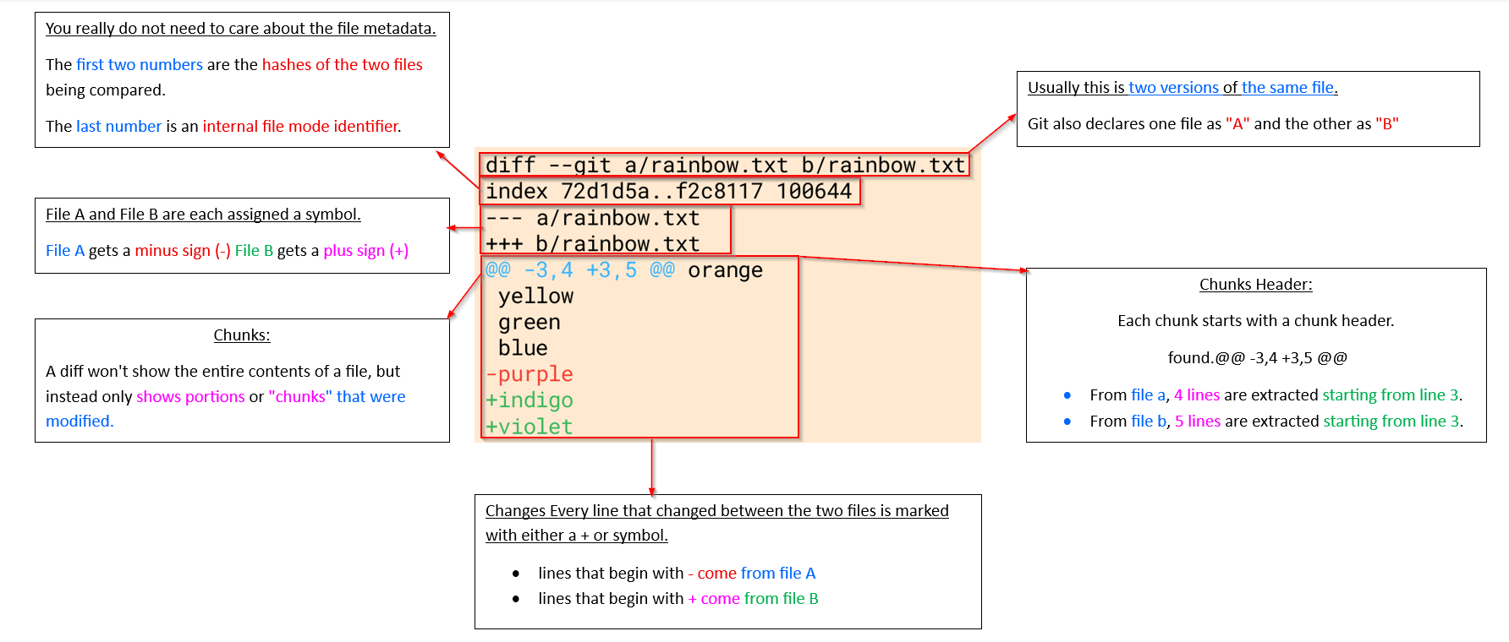

Git DIFF:
- git stash – check unstaging changes for multiple files
- git diff <<filename>> - specific file name
- git diff head – show unstaging and staging changes both
- git diff --staged/cached – list the changes between the staging area and our last commit
- git diff branch1:file1 branch2:file1 – list the changes between two branches in file1
- git diff <<commit1hash>> <<commit2hash>> – list the changes between two commits

GIT Stash:
- git stash – save changes not committed
- git stash pop – pop out the stashed saved changes in any branch
- git stash apply – it will still hold the changes even after applying the changes. unlike GIT STASH POP is not one times used.
- git stash list – to display all the stashes
- git stash apply stash@{3} – it will apply the 3 stash changes
- git stash drop stash@{2} – delete any particular stash
- git stash clear: to clear out all the stash

PART-4 (GIT)

- Detach Head:
Ex: GIT CHECKOUT <<CommitID>>

- Goto just previous commit
Ex:
- GIT CHECKOUT HEAD~1 (parent commit – one previous commit)
- GIT CHECKOUT HEAD~2 (grandparent commit – two previous commit)

- Reattach Head:
Ex:
- GIT SWITCH <<branchname> -- Head reset to original position
- GIT SWITH <<new branch name>> -- create a new branch

- Discard changes with GIT CHECKOUT HEAD.
- GIT CHECKOUT HEAD <<filename>>
- GIT CHECKOUT -- <<filename>>

- GIT RESTORE:
- Git Restore is a modern, flexible command for undoing changes.
- Its main job is to restore files in your working directory from the staging area or a previous commit.
Command | Use Case | What It Does
git restore --staged <file> | Unstage a file. | Moves a file from the staging area back to the working directory. Safe.
git restore <file> | Discard local changes. | Reverts a file to match the last commit. Destructive - loses work.
git restore . | Discard all local changes. | Reverts all modified files in the current directory. Very destructive.
git restore --source=<hash> <file> | Get an old version of a file. | Replaces a file with its version from a specific past commit.

Discard changes using RESTORE:
- git restore <<filename>> -- restore file status to last commit
- git restore -- source HEAD~2 <<filename>> -- show the file status before two commits ago
- git restore --staged <<API.KEY>> -- Remove the file from staging.

- GIT REVERT: It creates a brand-new commit which reverses/undos the changes from a commit
Command / Flag | Description
$ git revert a8b4b75 | Reverts a specific commit. Git will create a new commit that is the inverse of the specified commit and then open your configured text editor to let you edit the new commit message.
$ git revert -e HEAD~2 | This is the default behavior. It opens the text editor to let you modify the commit message for the new revert commit before it is created.
$ git revert -n a8b4b75 | Reverts the changes from the specified commit but does not create the new commit. The inverted changes are applied to your working directory and staging area, giving you the chance to modify them further or combine multiple reverts into a single commit.
$ git revert --no-edit a8b4b75 | Reverts the commit and creates the new revert commit without opening the editor. The new commit will have a default message like "Revert 'original commit message'". This is useful for scripting or when you're sure you don't need to change the message.
$ git revert -m 1 <merge_commit_hash> | Required when reverting a merge commit. A merge commit has multiple "parent" commits (usually two). This flag tells Git which parent's branch history to follow, effectively undoing the changes brought in from the other parent. The parent number is typically 1 for the branch you were on when you merged.

- Undo commit - REVERT:
  - git revert <<commit-Hash>> (It creates a brand-new commit which reverses/undos the changes from a commit. )

- GIT RESET:
- It moves your branch back to an earlier commit.
- Depending on the mode, it can also modify your working directory or staging area.

Mode | Command | Effect
Soft | git reset --soft <commit> | Keeps your changes staged
Mixed (default) | git reset <commit> | Keeps your changes unstaged
Hard | git reset --hard <commit> | Deletes your changes completely

- Undo commit - RESET:
  - git reset <<commit-Hash>> (Soft)
    - To undo those commits, you can use git reset <<hashcommit>>
    - Create a new branch. Save the change in new branch
    - Switch back to original branch. The changes are gone
  - git reset --hard <<commit-Hash>>

- Undoing change - Time Travel in GIT:
  - git checkout <<commit-Hash>> -- Detach head
  - git switch <<branch name>> -- reattach the head; set the head back to initial position
  - git checkout HEAD~1 -- Go back one commit back

- Discard changes using CHECKOUT:
  - git checkout head <<filename>>
  - git checkout -- <<filename>>

PART-1 (GITHUB)

- Public vs Private Repository:
Feature | Public Repository | Private Repository
Visibility | Visible to everyone on the internet. Anyone can view the code, issues, and commits. | Only visible to you and collaborators you explicitly invite.
Access Control | Anyone can fork, clone, and view the repository. | Only invited collaborators can view, clone, or push to it.
Use Case | Open-source projects, educational demos, portfolio code samples, community collaboration. | Proprietary code, confidential projects, internal team work, or personal experiments.
Cost | Free (unlimited public repos for all users). | Free for individuals with limited collaborators, but teams may need paid plans for advanced permissions and features.
Forking | Anyone can fork your repository. | Others cannot fork unless the repo is made public.
Searchability | Indexed by search engines and GitHub search. | Hidden from public search.
Collaboration | Open collaboration — contributions can come from anyone via pull requests. | Restricted collaboration — only invited members can contribute.
Security | Less secure (since code is visible to everyone). | More secure (access is restricted).
Examples | Linux Kernel, TensorFlow, React, Bootstrap. | Company projects, private scripts, or client-specific apps.

- GIT CLONE <<URL>>: clone a repository

- GIT REMOTE:
    - GIT REMOTE –v: To view any existing remotes for your repository.

    - GIT REMOTE Add <<name>> <<url>>: Add Designation repository name (mostly we name is ‘origin’)
      - Ex: git remote add origin https://github.com/DevOps-MATT1/Demo1.git

    - GIT REMOTE RENAME <<old>> <<new>>
      - Ex: git remote rename otigin origin

    - GIT REMOTE remove <<remotefoldername>>: remove remote folder
      - Ex: git remote remove origin

GIT PUSH:
  - git push <<remotename>> <<branchname>>: push code in github
    - Ex: git push origin master

  - git push origin <<localbranchname>>: <<githubNewbranchname>>: git push from local branch to new remote branch
    - Ex: git push origin master : newfeature

  - git push –u origin <<githubbranchname>>: Sets upstream tracking (shortcut for future GIT PUSH)
    - Ex: git push –u origin master

GIT FETCH:
  - git fetch <<remotename>> : get code from the remote repo in github
    - Ex: git fetch origin

  - git fetch <<remotename>> <<branchname>> : get code from the remote repo in github
    - Ex: git fetch origin newfeature

  - git push –u origin <<githubbranchname>>: Sets upstream tracking
    - Ex: git push –u origin master

